**Vegetation Management Autofill**

**Instruction Set | esankar@nelson.ca**

Purpose: Vegetation Management Fulcrum App became depreciated and lost some of its autofill functionality late 2021.

Overview: The vegetation management app runs on Mapbox and PythonAnywhere. Mapbox has a coordinate system grid of the city of Nelson. Fulcrum automatically finds the location of the record being made and changes it into geodesic XYZ coordinates. These geodesic coordinates are run through PythonAnywhere and compared to the bounds created on Mapbox to classify zone/TT area.

Fixes as of May 2022:

* Updated API key
  + Companies often depreciate legacy API keys and update them because they do not expire, so it’s a huge security risk.
  + 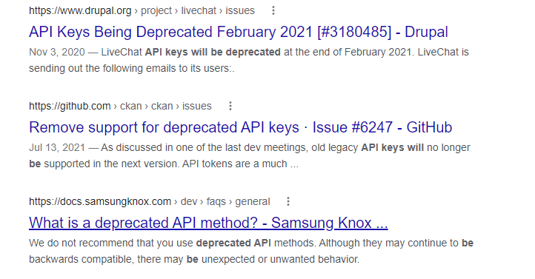
  + To address this, go to:
  + 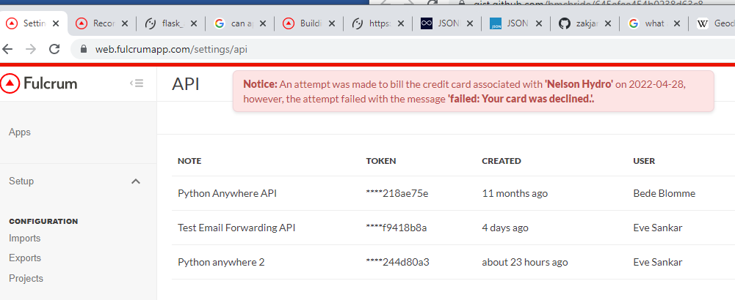
  + Create a new API key, then copy-paste it into line 55 of flask_app.py. You can forget about the old one.
* Patched JSON issue
  + <https://www.pythonanywhere.com/user/MLynnNelson/files/var/log/mlynnnelson.pythonanywhere.com.error.log>
    - Go to the error log and copy-paste whatever errors show up.
    - Example:
    - 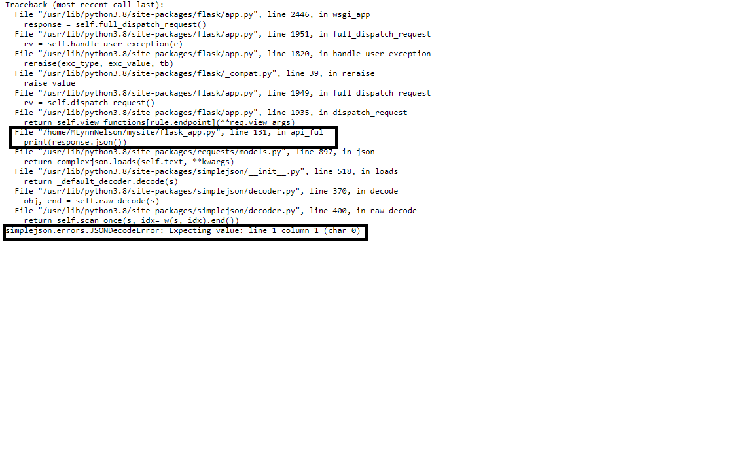
    - You can see that the program stopped running on line 131 here of flask_app.py, even though the program’s longer than that. Therefore, an error was thrown. The error is shown at the bottom.
* Updated calling of variables in Python
  + Original programmer called variables in flask_app by my_info[‘data’][‘created_location’][‘longitude’].
    - I changed it all to my_info[‘data’][‘longitude’] (format example). In future versions of Python, you may have to change it back. I’m writing to you from v.3.8.
* Updated Python
  + Obvious from above writing. Update Python, check the documentation, it’ll tell you what little things need to be changed. Do it.

Bugs to be patched (but still functional as of writing):

* simplejson.errors.JSONDecodeError: Expecting value: line 1 column 1 (char 0)
  + Fulcrum likes shutting us down sometimes when we get this error too much! To future programmers – this is the first time I’m writing anything to do with JSON. Sorry. But it seems like when you click to test the webhook, it gives us this. This makes sense to me because we’re sending blank packets. Works from app as we’re sending actual information.
* Again, because of the error above, you might have to click to turn on the webhook again.
  + 